Lab 6 – Ultrasonic Sensor

Prepared for:

Professor Bill Stefunak

Submitted by:

Graeme Judge and Sean Berkvens

04/07/2020

Electronic Systems engineering (ESE Year 2)

Conestoga College

**Main.c**

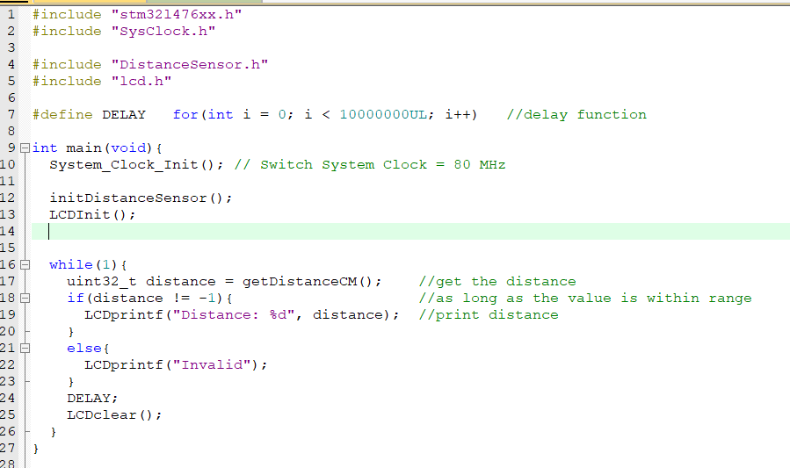

**DistanceSensor.c**

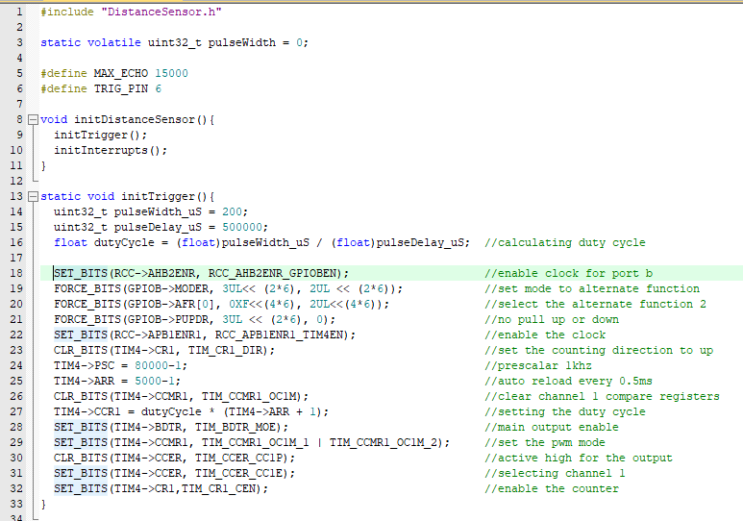

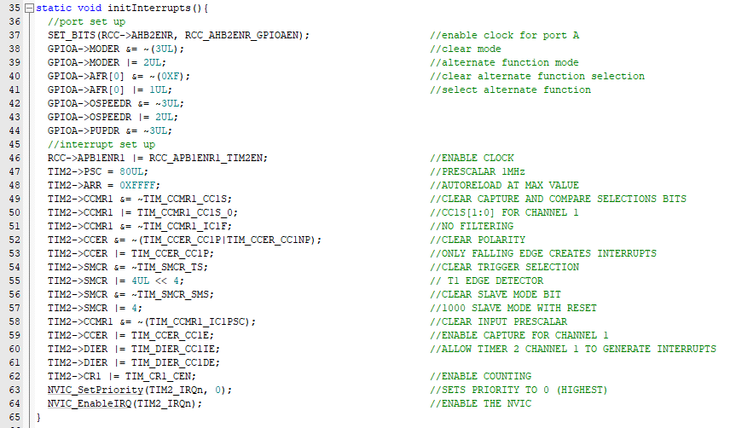

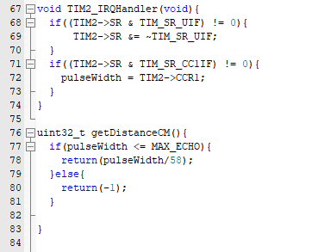

**DistanceSensor.h**

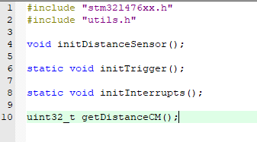

**Working images**

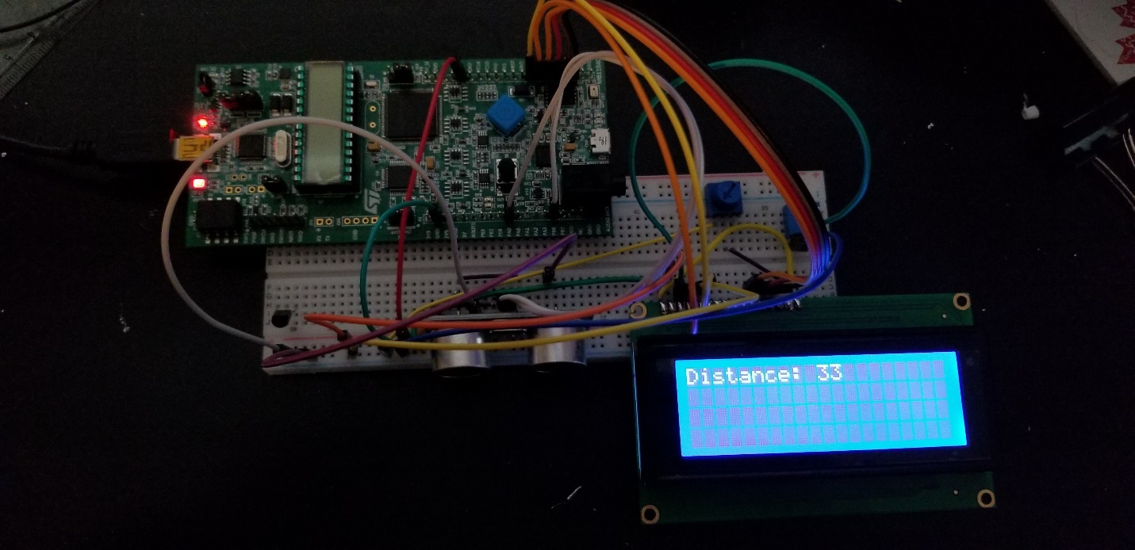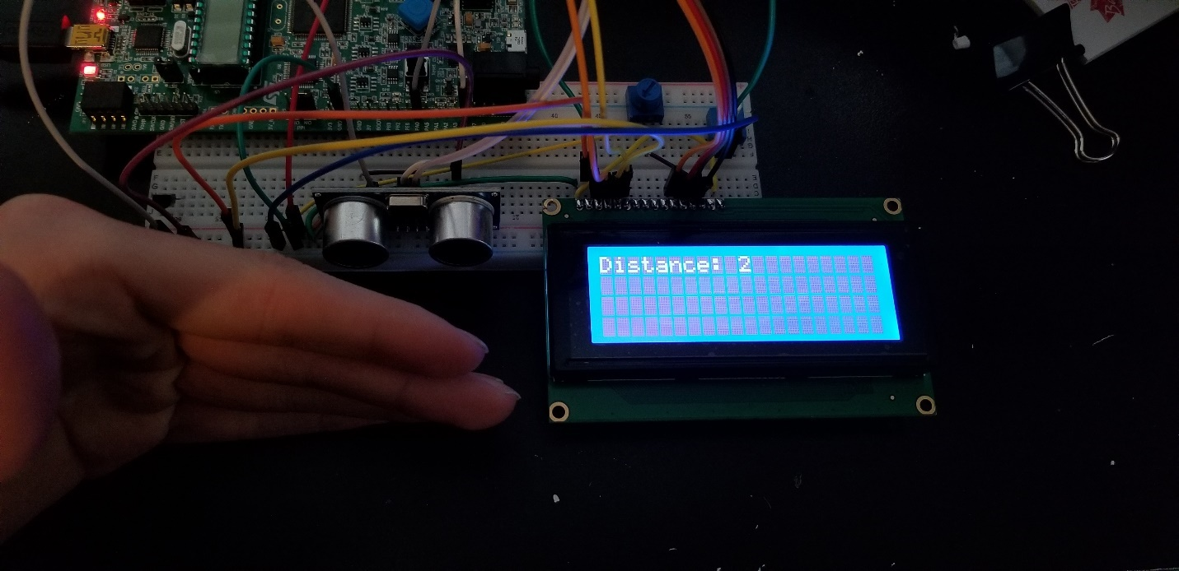

**Circuit diagram**

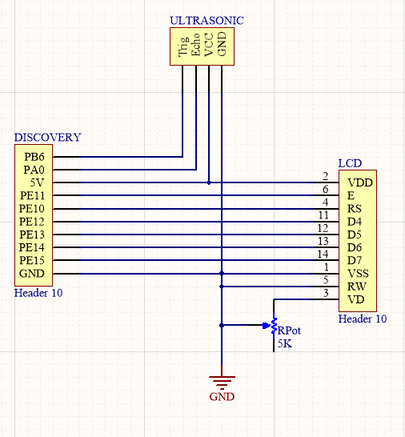

**Demo**

<https://youtu.be/ohV1teXcHhY>